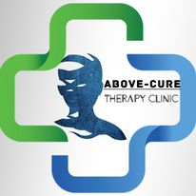

PROJECT : Above Cure Therapy Clinic

PROJECT MEMBERS:

|  |  |  |
| --- | --- | --- |
| **Faculty Name:** | **Sir Saddam Hussain** | |
| **Batch:** | 2308B | |
| **Group:** | Above Cure Therapy Clinic | |
| **Serial No:** | **Student ID:** | **Student Name:** |
| 1: |  | Arham Khan |
| 2: |  | Sheikh Huzaifa |
| 3: |  | Sunain Imran |
| 4: |  | Alyan Sunain |

Acknowledgement

*The first, we would like to express my special thanks of gratitude to my teacher SIR Saddam who helped a lot in finalizing this project within the limited time frame, valuable counseling and assistance for the accomplishment of this project. Secondly, we would also like to thanks the e-project team at Aptech Head Office, who gave as the opportunity to do this interesting and wonderful project about Jensen Decors*

*TASK SHEET*

|  |  |  |  |  |  |  |
| --- | --- | --- | --- | --- | --- | --- |
| PROJECT | | **Project**  **Title** | | | **Date Of Preparation Of Activity Plan** | |
| No. | *Tasks* | A  B  O  V  E  C  U  R  E | ***Actual start Date*** | ***Actual Days*** | ***Team-***  ***Mate***  ***Name*** | ***Status*** |
| 1. | *Home Page*  *Doctors*  *Departments*  *Services* | 6  -  D  E  C  -  2  0  2  3 | 30  -  D  A  Y  S  - | *Huzaifa* |  |
| 2. | *About us*  *Location* | *Arham* |  |
| 3. | *Contact Us* | *Sunain* |  |
| 4. | *Gallery* | *Alyan* |  |
| 5. | *Management* | *All* |  |
| 6. | *Ui/Ux design* | *Huzaifa* |  |
| 7. | *Documentation* | *Arham* |  |

Problem Statement:

Project Overview:

The Above Cure Therapy Clinic products website is a comprehensive online platform design to showcase and sell a wide range of Therapy Equipements and Therapy Services .The website aim to provide an engaging user experience while displaying products and facilitating easy navigation for users.it leverages HTML 5, JavaScript and Geolocation to create an interactive and responsive web application.

Project Objective:

The objective of the project are as follows:

1. Create an attractive and user-friendly website for Above Cure Therapy Clinic products.
2. Provide user with an easy-to-navigate interface to explore various product categories.
3. Implement a product categorization system based on both type and brand.
4. Offer the ability to view product details, download product documentation and compare different products.
5. Include a “contact-us” page with address information displayed using Geolocation Project scope

1.Home page:

Section with suitable Logo.

Header Section contains Navbar and the Links to get on Other Webpages.

2.About Page:

having all the Information About the Website.

3.Contact Us:

Contains the Number and email of the Website.

4.Services:

Showcase of the services of the Above Cure Therapy Clinic.

1. Accidents
2. Bone cracks and Internal Pain
3. Internal Injuries

4.Departments:

Shows the other branches and locations of Above Cure Therapy Clinic.

5.Gallery:

A huge collection of images showing the physical therapy processes and also the products that can be used for homemade physical therapy sessionsl like Lotions, Oils, Hot Water puffs, etc…

6.Locations:

A webpage of Above Cure Website to show the location of Above Cure Therapy Clinic located.

7.Doctors:

Shows the images of Doctors who are working at Above Cure Therapy Clinic.

**IMAGES**

**HOME PAGE:**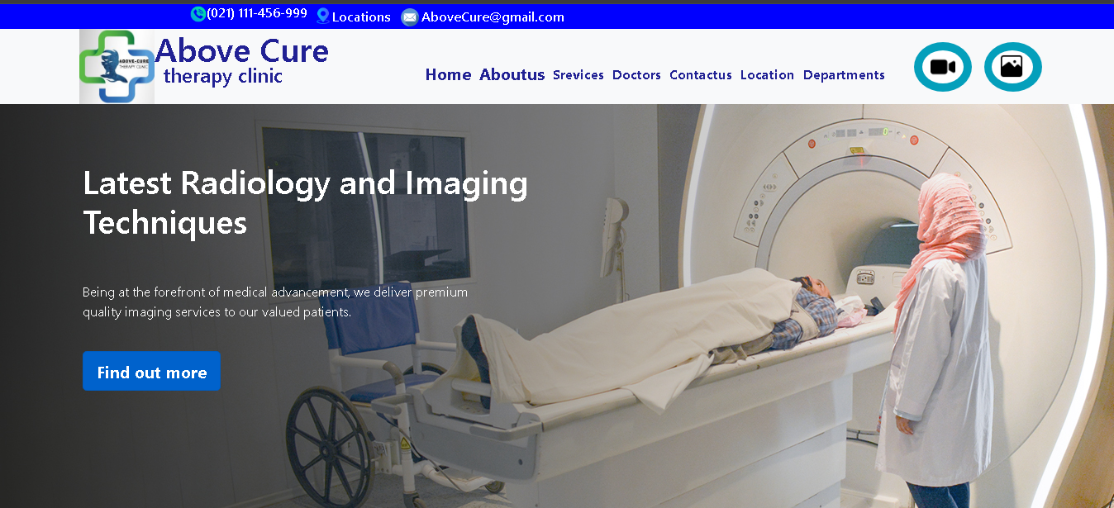

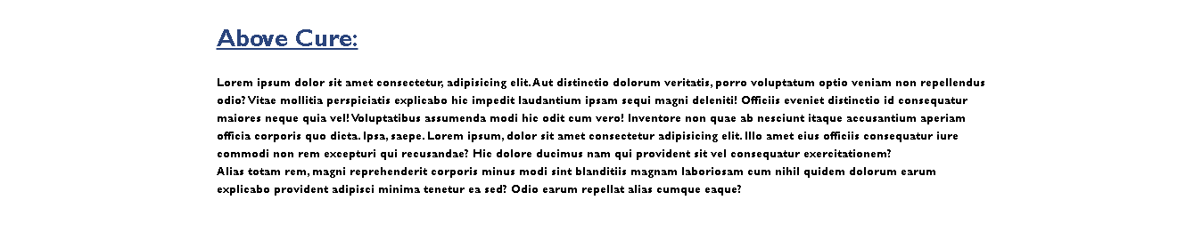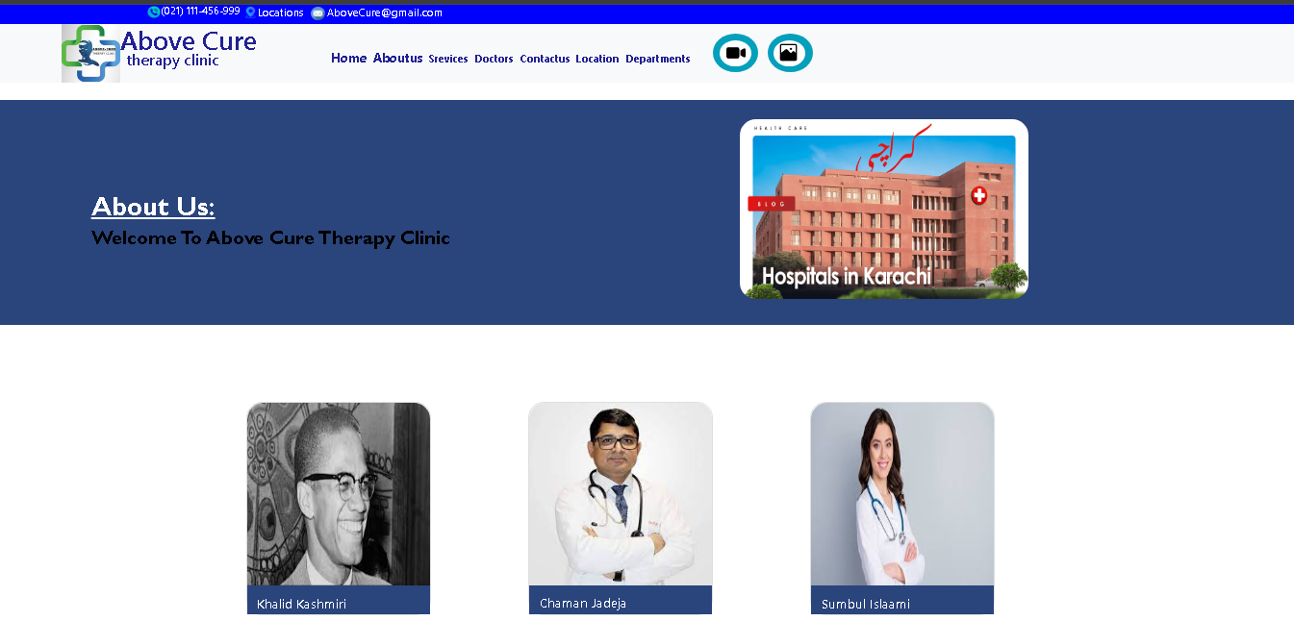**ABOUT US:**

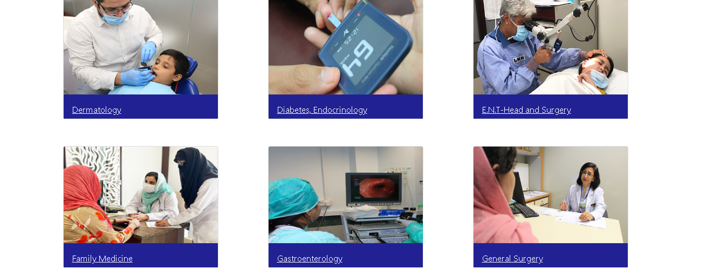**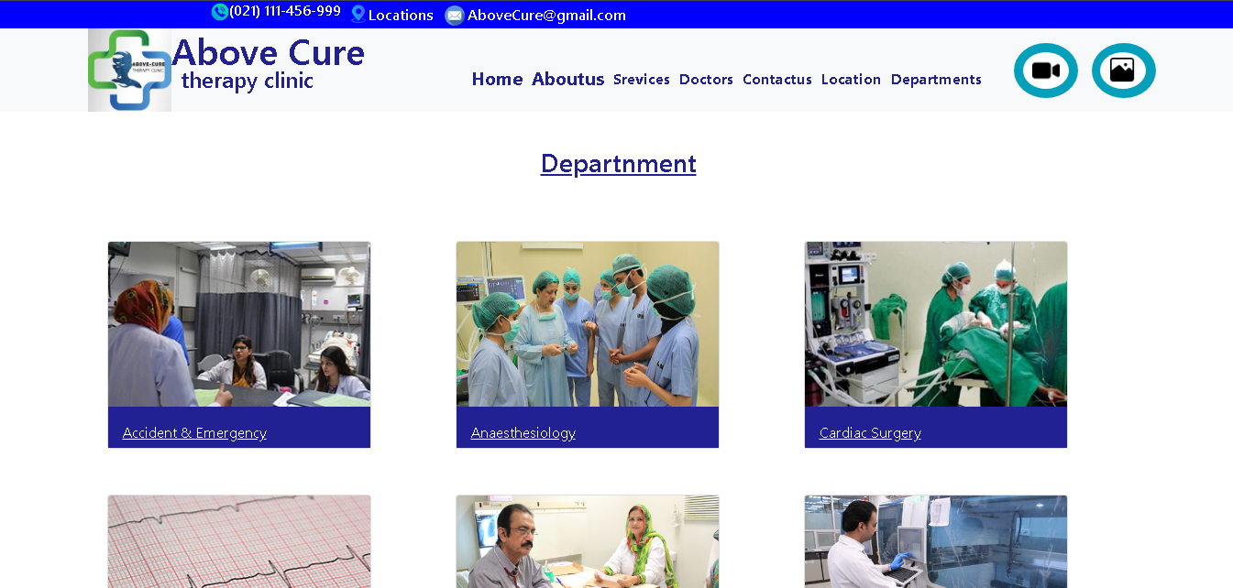DEPARMENTS:**